CREATE TABLE Genres (

genre_id INT PRIMARY KEY AUTO_INCREMENT,

name VARCHAR(100) NOT NULL UNIQUE

);

CREATE TABLE Artists (

artist_id INT PRIMARY KEY AUTO_INCREMENT,

name VARCHAR(255) NOT NULL UNIQUE,

country VARCHAR(100),

debut_year INT

);

CREATE TABLE Albums (

album_id INT PRIMARY KEY AUTO_INCREMENT,

title VARCHAR(255) NOT NULL,

release_year INT,

artist_id INT,

genre_id INT,

FOREIGN KEY (artist_id) REFERENCES Artists(artist_id),

FOREIGN KEY (genre_id) REFERENCES Genres(genre_id)

);

CREATE TABLE Songs (

song_id INT PRIMARY KEY AUTO_INCREMENT,

title VARCHAR(255) NOT NULL,

duration TIME NOT NULL,

album_id INT,

artist_id INT,

genre_id INT,

FOREIGN KEY (album_id) REFERENCES Albums(album_id),

FOREIGN KEY (artist_id) REFERENCES Artists(artist_id),

FOREIGN KEY (genre_id) REFERENCES Genres(genre_id)

);

CREATE TABLE Playlists (

playlist_id INT PRIMARY KEY AUTO_INCREMENT,

name VARCHAR(100),

created_at DATE

):

CREATE TABLE PlaylistSongs (

playlist_id INT,

song_id INT,

PRIMARY KEY (playlist_id, song_id),

FOREIGN KEY (playlist_id) REFERENCES Playlists(playlist_id),

FOREIGN KEY (song_id) REFERENCES Songs(song_id)

):

Python Interface/Logic:

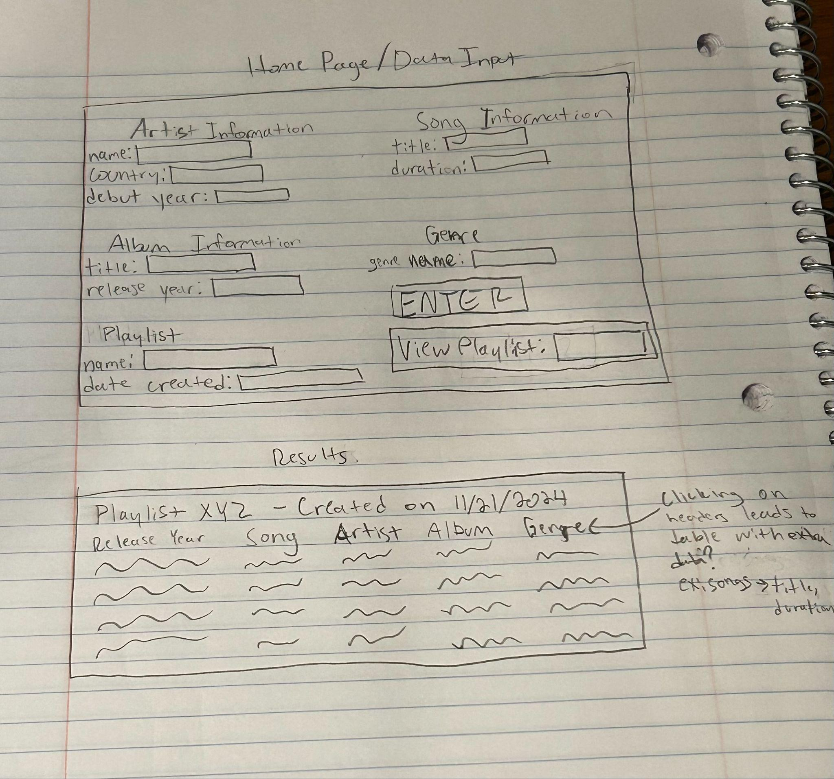

On the home screen, the user will input the data associated with the song, album, artist, which playlist it will be added to, and the genre - if there is a way that there could be an autofill, so that when multiple songs from the same album are entered it is less redundant when filling the information in, that would be helpful. The “Enter” button would be used so that the user could enter all of the information to the database, and “View Playlist” would allow the user to enter the name of the playlist they want to view (or possibly select it from a dropdown menu if possible), and then have a window displaying the playlist in a format like the illustration. From the playlist screen, if there is a way to click on the column header to view that table more in depth, so that if you pressed the “song” header, you would be able to see both the song title, and the duration from the data that was entered for it.